Nutrition Education and Breastfeeding Time Study (NEBFTS): MI-WIC Activity Descriptions

To review the Time Study Instruction video, go to: mphievents.com>Online Learning>Time Study

To access the Time Study Data entry screen in the clinic module, go to:
MI-WIC > CLINIC > MISCELLANEOUS > TIME STUDY ENTRY
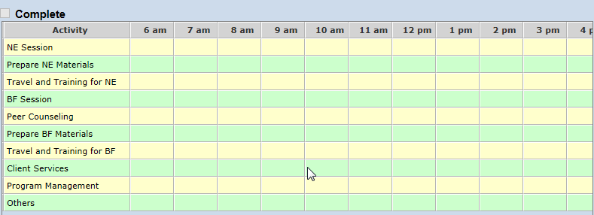

Definition and Description of Nutrition Education Activities:
Definition: a trained professional conducts nutrition education. It includes both the communication of food and nutrition facts appropriate to the needs of the client and the evaluation of the educational program's effectiveness. Nutrition education should encourage the client's motivation and increase knowledge, awareness and skills in making informed decisions about diet and nutrition practices. NE includes four steps:
1. Evaluation of the individual's nutrition knowledge and eating practices, as well as health and socio-cultural status. Determination of educational needs and objectives.
2. Development of an instructional program that meets identified objectives and is compatible with past experiences, reading and learning abilities.
3. Implementation of the instructional program.
4. Evaluation of comprehension to determine the instructional program's effectiveness.

Description: Activities that must be recorded as NE activities include any one of the three classifications of activities:
- Nutrition Education sessions
- Nutrition Education counseling
- Nutrition Education support services

Nutrition Education (NE) Session may include:
- Risk eligibility
- Nutritional objectives
- Reviewing the previous NE Plan and objectives with the client(s).
- Nutritional value of eligible foods
- WIC food consumption by participant(s)
- Diet/health services relationship(s)
- Nutrition facts that are appropriate to each participant’s cultural nutrition/health needs and level of understanding.
- Counseling, including the development of nutrition care plan and documentation of the counseling session.
- Creating a NE Plan and objectives with clients.
- Nutrition education (individual or group) based on client's individual needs and
concerns, socioeconomic status, food preferences, cultural values and available resources. Includes use of client-centered counseling methods.
- Prioritizing health concerns with clients, for use during nutrition counseling.
- Development and Documentation of a Nutrition Care Plan
• Home and hospital visits that allow clients to discuss nutrition related problems and
decide behavioral changes to resolve or modify the problem

Does NOT Include:
• Completion of MI-WIC Medical and Nutrition questions
• Anthropometric data or hemoglobin/hematocrit data collection and recording
• Facilitation of support groups
• Provision of nutrition related referrals

Preparing NE Materials may include:
• Creation, adaptation, and review of NE materials (including lesson plans & modules)
• Orientation, supervision, and staffing of NE personnel to provide NE encounters and
services (including time spent arranging for services provided by other community
agencies, i.e., EFNEP).
• Documentation of NE records.
• Evaluation of NE services (development of methods to measure client comprehension
and retention of NE concepts, follow-up and eval of NE referrals, completion and
processing of NE time study, review of NE program participation and effectiveness).
• Contact with clients to assist in orientation to wichealth.org, troubleshooting
completion of online nutrition modules, and follow-up re: NE questions.
• Developing/personalizing Internet nutrition education flyers, i.e., for wichealth.org.
- Translator services by staff members are in support of breastfeeding and nutrition services.

Travel and Training for NE may include:
• Staff travel and training time for NE training, in-services, and conferences

BF Session (Breastfeeding Promotion and Support may include:
• Provision of information, education and counseling regarding breastfeeding.
• Staff time for breastfeeding outreach/community network activities.
• Staff time for promotion of a positive clinic environment, including time spent
displaying breastfeeding posters and literature, and time spent securing and
maintaining a dedicated breastfeeding area.
• Time spent training peer counselor staff and collaborating with peer counselors.
• Demonstration/teaching clients hand expression and breast pump assembly and use of pump.
• Telephone contacts to assist in BF problem-solving, education, reinforcement of
breastfeeding messages and goals, and other BF support needs.

Peer Counseling
• If peer counselors are employees of the local agency, they participate in the Time Study. If they are paid by the Peer Counselor Grant funds, they do not participate in the Time Study.

Preparing BF Materials may include:
• Creation, adaptation, and review of BF materials.
• Orientation, Supervision, and Staffing of BF personnel to provide BF services.
• Documentation of BF records.
• Evaluation of BF services (development of methods to measure client comprehension
and retention of BF concepts, follow-up and eval of BF referrals, completion and
processing of BF time study, evaluation and documentation of breastfeeding
promotion activities).
• Review or development of educational and outreach material
- Translator services by staff members are in support of breastfeeding and nutrition services.

Travel and Training for BF may include:
• Staff travel & training time for BF promotion and education training, in-services, and
Conferences

Client Services
• Not applicable for use currently.
Program Management
• Not applicable for use currently.

Others may include:
• Time that does not meet the definition of a qualifying NE or BF activity, but where it
is necessary to record time in the system for the column sum to total 60 minutes*
• Time for meal and rest breaks (paid or unpaid)
• Time paid for by Program(s) other than WIC
*Note: It is not necessary to record all staff time meeting this activity description - record
only where required by MI-WIC to total 60 minutes in an hourly column. This value does
not count toward either NE or BF Promotion and Education.

Thank you for participating in the Nutrition Education and Breastfeeding Time Study by completing Time Study data entries for all participating staff. Federal WIC regulations require agencies to spend a minimum of 1/6 WIC funding on nutrition education (NE), and an additional amount of funding (as designated annually by USDA) on breastfeeding promotion and education. The State of Michigan WIC Division collects information from local agencies regarding time and money spent on NE and breastfeeding expenditures.

