Converting linear measurements fractions for MIWIC:

Measurement | Measurement Reduced/same as* | Measurement Reduced/same as* | Measurement Reduced/same as* | Entered in MIWIC as
 |  |  | 1/16” | 1
 |  | 1/8” | 2/16” | 2
 |  |  | 3/16” | 3
 | 1/4” | 2/8” | 4/16” | 4
 |  |  | 5/16” | 5
 |  | 3/8” | 6/16” | 6
 |  |  | 7/16” | 7
1/2” | 2/4” | 4/8” | 8/16” | 8
 |  |  | 9/16” | 9
 |  | 5/8” | 10/16” | 10
 |  |  | 11/16” | 11
 | 3/4” | 6/8” | 12/16” | 12
 |  |  | 13/16” | 13
 |  | 7/8” | 14/16” | 14
 |  |  | 15/16” | 15
*Usually measurements are ‘read’ in the ‘reduced’ format commonly seen with height, length, or head circumference tapelines, for example, 15 ½ but the correct way to enter that number in the ‘in*’ column is 15 and in the ‘1/16’ column is 8. Data entry for linear measurements (height, length, head circumference) is the same for infants, children, and adults. See below:

Measurement MI-WIC Entry Example

20 1/16 inch |  | 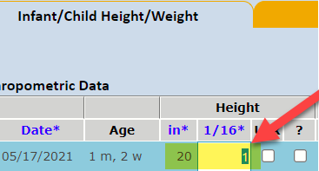
20 1/8 inch |  | 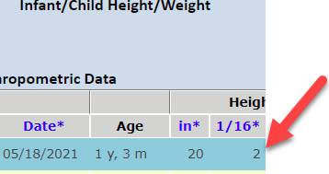
20 ¼ inch |  | 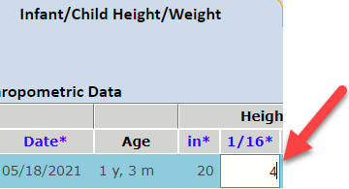
20 ½ inch |  | 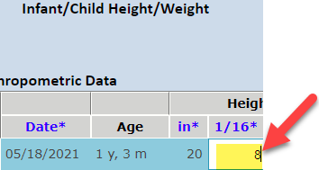
20 ¾ inch |  | 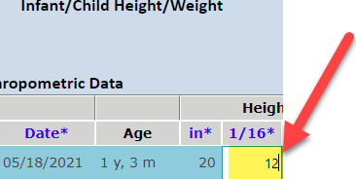
 |  | If you have questions, please contact Anthro trainer Joyce Bryant bryantj5@michigan.gov

What would you enter for 20 7/8 inch?

