Laid Back Breastfeeding
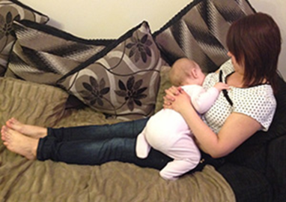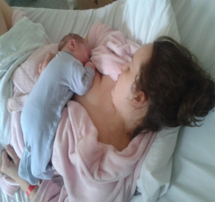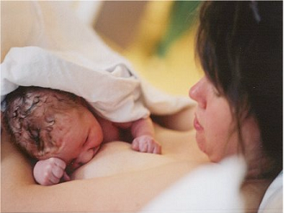
Laid-Back Breastfeeding is another way to nurse your baby, using the baby’s inborn reflexes and a comfortable laid back position for the Mother, so the baby can easily latch on to the breast.
When trying out Laid-Back Breastfeeding, moms are encouraged to find a comfortable position on a bed, couch or chair in which she can lean back (although not lying all the way back) as if she were reclining to watch TV. Mom should be fully supported and comfortable with her hands free so that she can be in this position for up to one hour. In this semi-reclined position, mom’s body supports the baby. The baby is placed on his tummy on top of her body, with the baby’s head near the breast (or C-section moms can position the baby away from the abdominal incision). Then, the baby is allowed to find the breast and self-attach. Mom is encouraged to make sure that the latch does not hurt; however, often the baby has a deeper latch than with more traditional holds.
Laid-Back Breastfeeding is wonderful in that it puts less strain on mom’s body, allows her to fully relax, and supports the baby’s entire body. And self-attachment, when baby finds the breast on his own, is simple and can be a big confidence builder. New Moms often get bombarded with positions and “rules” for breastfeeding and become overwhelmed and frustrated, wondering if they will be able to remember all the different positions. But with Laid-Back Breastfeeding, there are no rules, steps, or holds and latches for mom to remember. Instead, mom relaxes and most babies self attach.

