MI-WIC Data Entry for Weight

Weighing Infants and Children Under Two Years Old (C1)
Infant and pediatric scales have a sensitivity to 1 ounce (oz).

Recording the measurement:
Write measurements in pounds (lbs.), ounces, and, if appliable, fractions or decimals.

Examples:
- Weight of 6 lbs., 4.8 oz. Record on form exactly as on the equipment.
- Weight of 28 lbs.,12 3/4 oz. Record on form exactly as on the equipment.

Confirming the measurement:
The confirming measurement must be within 1 oz for infants and C1.

Rounding the measurement:
- If the fraction of an ounce is greater than 0.5 or 1/2, round up.
- If the fraction of an ounce is less than 0.5 or 1/2, round down.
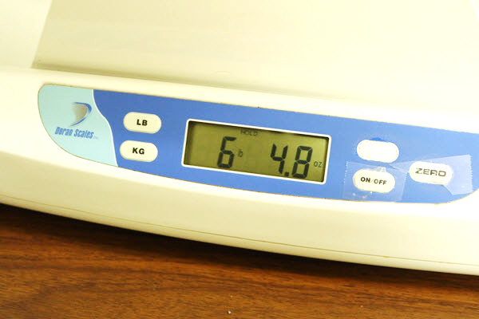
In this photo, the measurement reads 6 lbs. 4.8oz. Enter 6 lbs. 5 oz. into MI-WIC

Converting the measurement for MI-WIC:
All of MI-WIC’s weight measurements data are in pounds and ounces (oz). Enter actual pounds and ounces and round ounce fractions to the nearest ounce.
Examples:
- Digital scale: 30 lbs. 6.4oz. The decimal in the tenths place is less than 0.5, so round down to 6 oz. Enter 30 pounds 6oz into MI-WIC. Do not use Tab.
- Digital scale: 6 lbs. 4.8oz. The decimal in the tenths place is more than 0.5, so round 4oz up to 5oz. Enter 6 lbs. 5oz into MI-WIC. Do not use Tab.
- Beam scale: weight of 20 lbs. and 5 3/8 oz. The 3/8 is less than 1/2, so drop 3/8 and round ounces down to 5oz. Enter in MI-WIC as 20 lbs. and 5oz.
- Beam scale: weight of 28 pounds and 12 6/8 ounces. The 6/8 is more than 1/2 so round 12oz up to 13oz). Enter in MI-WIC as 28 lbs. and 13 lbs.

Weighing Children Ages 2 to 5 Years Old (C2-C5) and Adults
Adult scales have a sensitivity to 0.2 pounds (3.2 oz.) on a digital scale or 1/4lb (4oz.) on a beam scale. An adult scale is not sensitive enough to pick up an infant or C1’s one- or two-ounce weight change. If the child is uncooperative and held by an adult, then the weight is tared. To tare, weigh the adult with the child, then weigh the adult alone and subtract the adult’s weight to obtain the weight of the child.

Recording the measurement:
Write measurements in pounds, ounces, and, if appliable, decimals.

Confirming the measurement:
- Digital scale: within 0.2 pounds
- Beam scale: within 1/4 pound

Converting the measurement for MI-WIC:
Examples:
- Beam scale: Weight of 52 3/4 pounds*. Enter into MI-WIC as 52 lbs. 12 oz.
- Beam scale: Weight of 155 1/4 pounds*. Enter into MI-WIC as 155 lbs. 4 oz.
- Digital scale: Weight 45.2 lbs. Enter into MI-WIC and hit ‘Tab’ to convert the decimal into ounces as 45 lbs. 3 oz.**
- Digital scale: Weight 37.8 lbs. Enter into MI-WIC and hit ‘Tab’ to convert the decimal into ounces as 37 lbs.13 oz.**

*Converting pound fractions to ounces
Measurement | Equivalent Fraction(s) | MI-WIC Entry
1/16 |  | 1
2/16 | 1/8 | 2
3/16 |  | 3
4/16 | 2/8 or 1/4 | 4
5/16 |  | 5
6/16 | 3/8 | 6
7/16 |  | 7
8/16 | 4/8 or 2/4 or 1/2 | 8
9/16 |  | 9
10/16 | 5/8 | 10
11/16 |  | 11
12/16 | 6/8 or 3/4 | 12
13/16 |  | 13
14/16 | 7/8 | 14
15/16 |  | 15

** Tenths of a pound must be converted to ounces:
Decimal in Pounds | Equivalent Ounces
0.1 | 2
0.2 | 3
0.3 | 5
0.4 | 6
0.5 | 8
0.6 | 10
0.7 | 11
0.8 | 13
0.9 | 14

