DESCRIPTION OF BREAST PUMPS

MANUAL BREAST PUMPS (SINGLE USER)
Reason for Issuance | - Attempting to breastfeed or provide breast milk.  - Temporary issues such as engorgement, oversupply, plugged duct or sore nipples.  - For mothers who need to pump for Infrequent separation from their baby, such as part-time return to work, school or other reason.
Qualifications | - NPP, BP or BE
PUMP MANUFACTURER, MODEL AND DESCRIPTION
Ameda, Hand with Flexishield | The Flexishield Areola Stimulator™ provides increased stimulation and encourages the let-down reflex. | 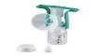
Medela, Harmony | The dual pumping pattern that mimic a baby's sucking for the let-down and expression phases of breastfeeding. The PersonalFit Flex™ Breast Shield is designed with a new 105◦ angle and oval shape to reduce pressure on the breast and optimize milk flow. | 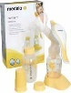
Hygeia, EnHande | Designed to ensure a direct flow from breast shield to milk storage container for maximum hygiene. One-piece valve system and fewer parts for easy assembly and cleaning. Silicone petal comfort massage shield helps with let-down. | 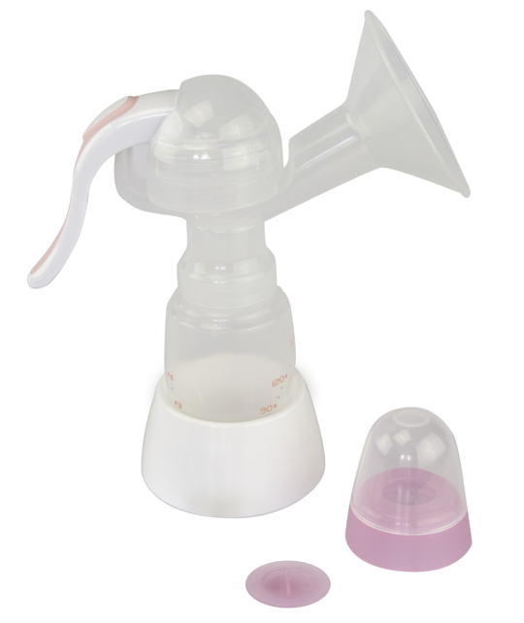

PERSONAL (SINGLE USER) ELECTRIC BREAST PUMPS
Reason for Issuance | - Experiencing separation for any period of time  - Returning to work/school  - Not appropriate for problems associated with initiating breastfeeding, poor latch, or temporary breastfeeding issues, such as engorgement or sore nipples.
Qualifications | - Categorized as exclusively breastfeeding (BE) and infant not receiving formula from WIC.  - Established breastfeeding for at least one (1) month.  - Client should receive only 1 personal use pump per pregnancy.
PUMP MANUFACTURER, MODEL AND DESCRIPTION
Hygeia, EnJoye/EnRiche | The EnJoye is a cordless pump. The EnJoye and EnRiche mimic the infant’s unique suckling patterns with customizable speed and pressure controls. | 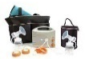
Ameda, Finesse | Comfortflow™ technology, separate speed and suction dials with 32 fully customizable options for multiphase pumping. | 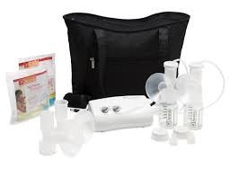
Medela, Personal Double | Single-user pump includes a double pump kit. Allows client to control suction strength and speed. | 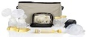

MULTI-USER ELECTRIC BREAST PUMPS
Reason for Issuance | - Difficulty initiating and/or maintaining an adequate milk supply  - Extended mother/infant separation  - Maternal/infant illness  - Desire to re-establish breastfeeding.  - Other special circumstances determined by the Breastfeeding Coordinator.
Qualifications | - Categorized as NPP, BP or BE  - Multi-user breast pumps should be issued for no longer than 1 month at a time. Situations requiring longer use must be re-evaluated at monthly intervals.
Each client will need their own attachment kit.
PUMP MANUFACTURER, MODEL AND DESCRIPTION
Ameda, Elite | Closed system eliminates the needs to clean and dry tubing. Able to control and adjust suction strength and cycling speed to mimic infant's suckling pattern. | 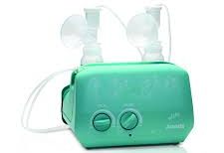
Hygeia, Endeare | Closed system eliminates the need to clean and dry tubing. Offers Customized Audio Recording Experience (CARE) for clients to record their infant's voice, cry or other sounds. Able to control and adjust suction strength and cycling speed to mimic infant's suckling pattern. | 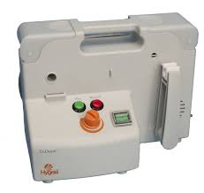
Medela, Lactina | Allows for client to control suction strength. | 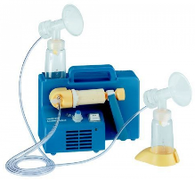
Medela, Symphony | Includes 2-Phase Expression that mimic a baby's sucking for the let-down and expression phases of breastfeeding. | 